Task 3 - Admin Dashboard with Chatbot
Name: Tanvi Khicchi
1. Register Page
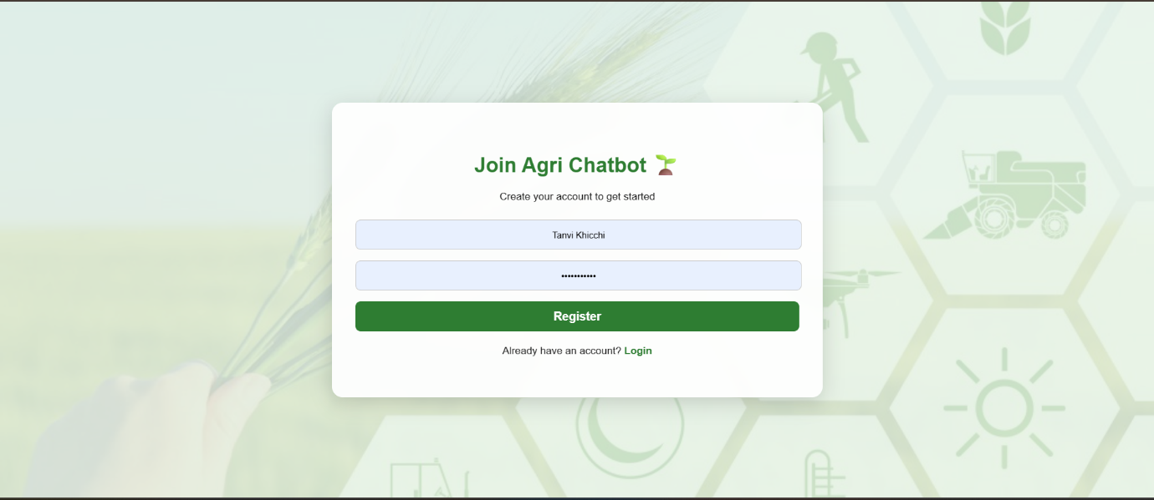
User registration interface for new users.
2. Login Page
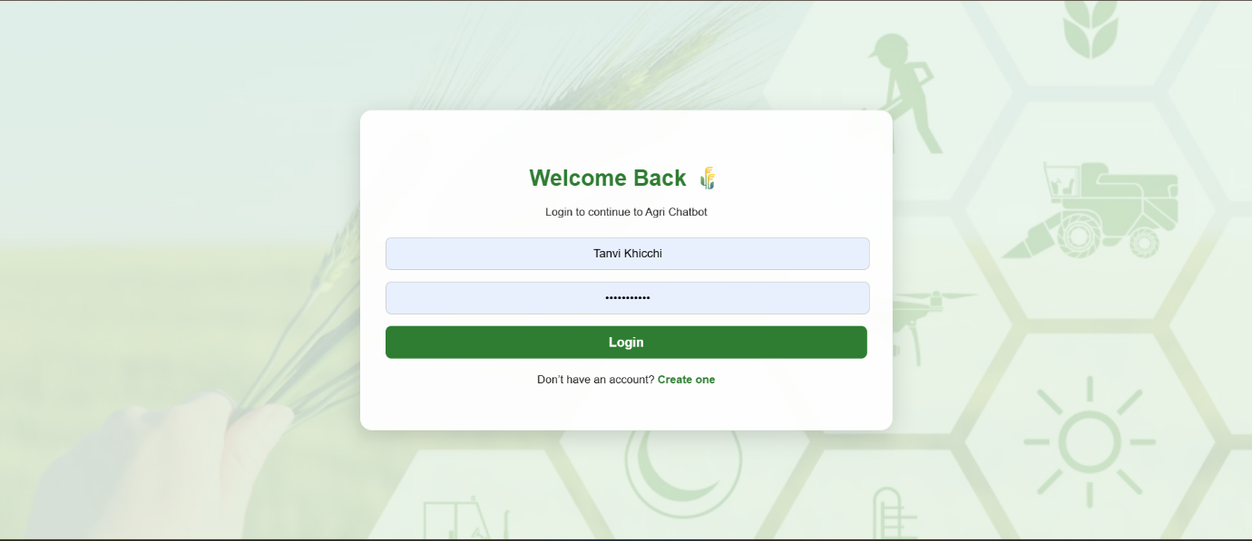
Secure login for existing users.

3. Chatbot Interface - Multilingual Support
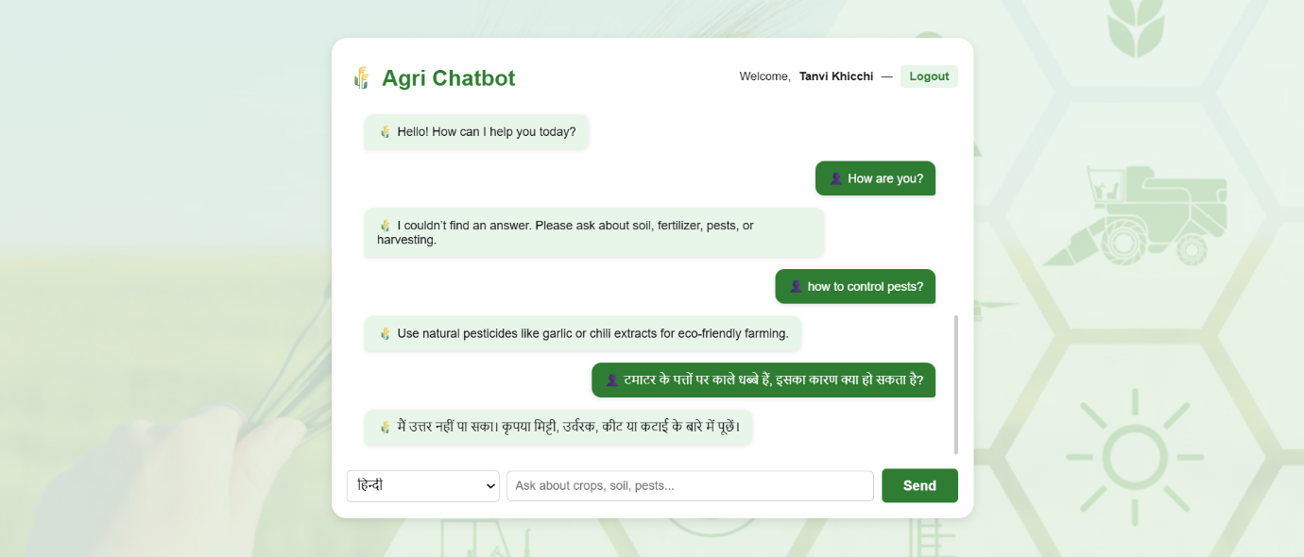
Allows users to interact with the chatbot in both English and Hindi, making the platform accessible and user-friendly for farmers across different regions.

4. Admin Login

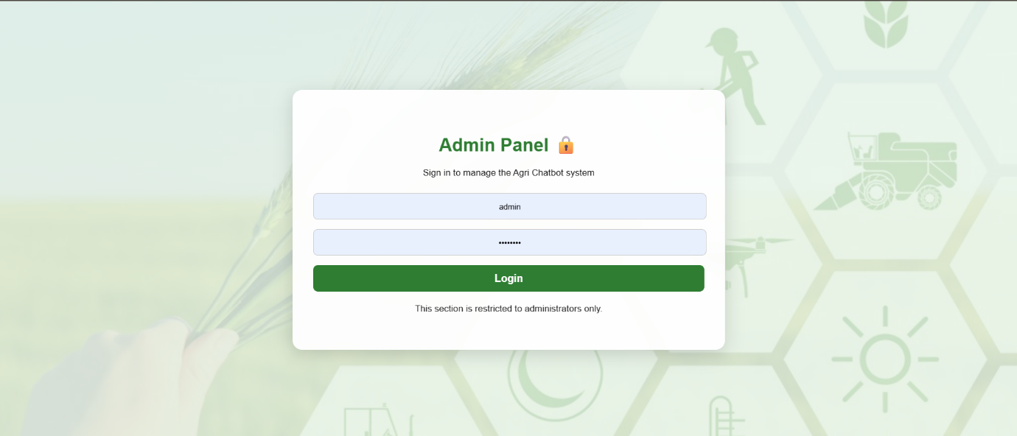
A secure login page exclusively for administrators to access and manage the dashboard, ensuring authorized control over platform operations.

5. Admin Dashboard

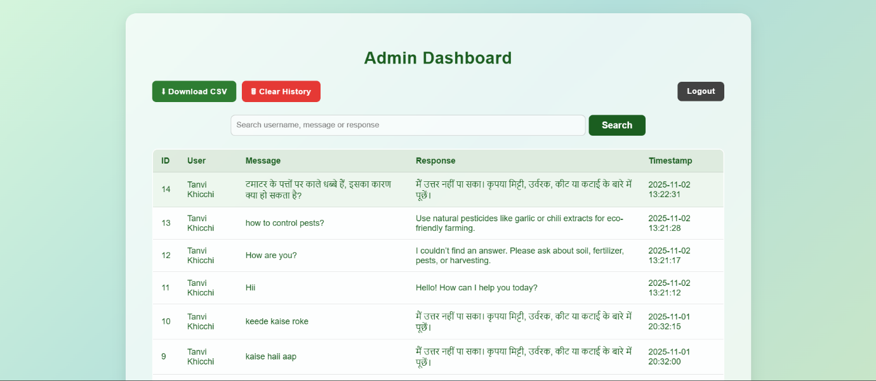
A centralized panel where admins can manage users, update content, and monitor chatbot activity for better system control and maintenance.

